Port-In FAQ

Q: Is VSHA billing or absorbing currently?
A: VSHA is billing all Port-In’s currently.

Q: What is VSHA’s Administrative Fee for billed ports?
A: VSHA’s Administrative Fee is $81.54 (09.01.2025)

Q: How much time do I have to find a unit? Voucher extension request?
A: VSHA will add 30-days to the voucher from your Initial Housing Authority. The family must request an extension and the housing authority will review the request.

Q: What is the rent amount I should be looking for?
A: Units that are affordable when the total gross rent (what the landlord is asking and the total of all utilities you would be paying for) is at or below the voucher payment standard. Review chart below. For utility allowance schedules please go back to the website.
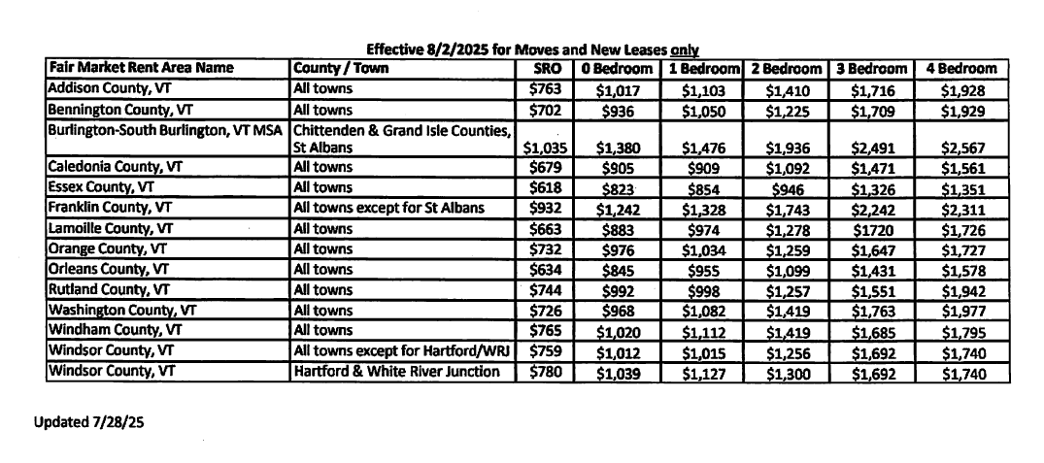
Q: Can I move into the unit before the paperwork has been processed?
A: VSHA will not advise nor suggest for you to do so. It must first be determined you are eligible for the unit, the unit must pass a Housing Quality Standards (HQS) Inspection, and the rent must be determined that it is a reasonable rent amount prior to your moving in to the unit.

Q: Hows is rent determined?
A: Your rent, which is referred to as the Total Tenant Payment (TTP) in this program, would be based on your family’s anticipated gross annual income less deductions, if any. HUD regulations allow Housing Authority’s to exclude from annual income the following allowances $480 for each dependent; $400 for any elderly family, or a person with a disability; and some medical deductions for families headed by an elderly person or person with disabilities. Annual income is the anticipated total income from all sources received from the family head, spouse, and each additional member of the family 18 years of age or older.

The formula used in determining the TTP is the highest of the following, rounded to the nearest dollar:
- 30 percent of the monthly adjusted income (Monthly Adjusted Income is annual income less deductions allowed by the regulations);
- 10 percent of monthly income;
- Welfare rent, if applicable ($223 in Chittenden County and $198 for all other Vermont Counties); or

